Sanity Check:::

Dir ii = 1
>> kp = ptStartInd:ptEndInd;
>> binX = 0:.005:2;
>> binY = binX;
>> distan = totalEdgDist(kp) ;
>> [n,~,~,ix] = histcn(points,binX,binY);
>> kpp = all(ix>0,2);
>> mean_dist = accumarray(ix(kp,:),distan(kpp),[],@nanmean,nan);
>> figure
imagesc(mean_dist)
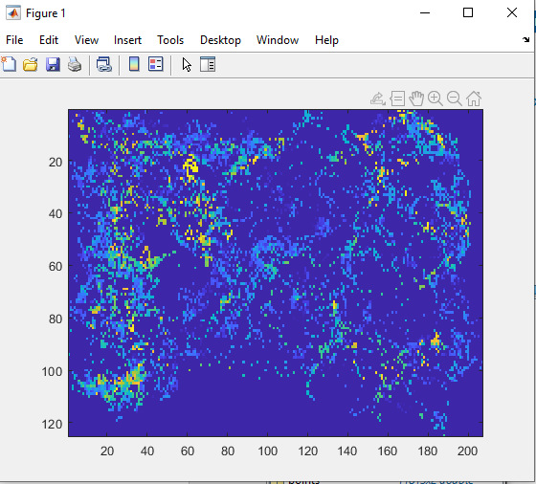

Ii = 2
Using same ^^
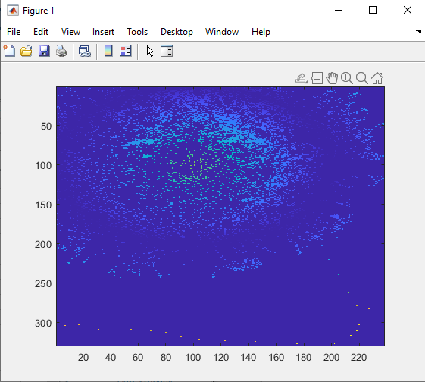

I = 3
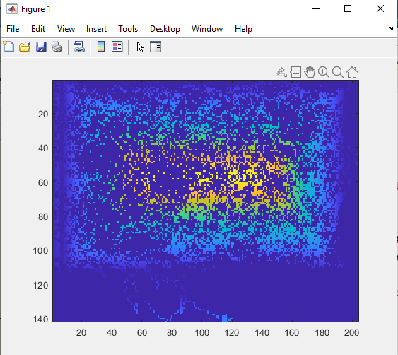

I = 4
binX = -1:.005:2;

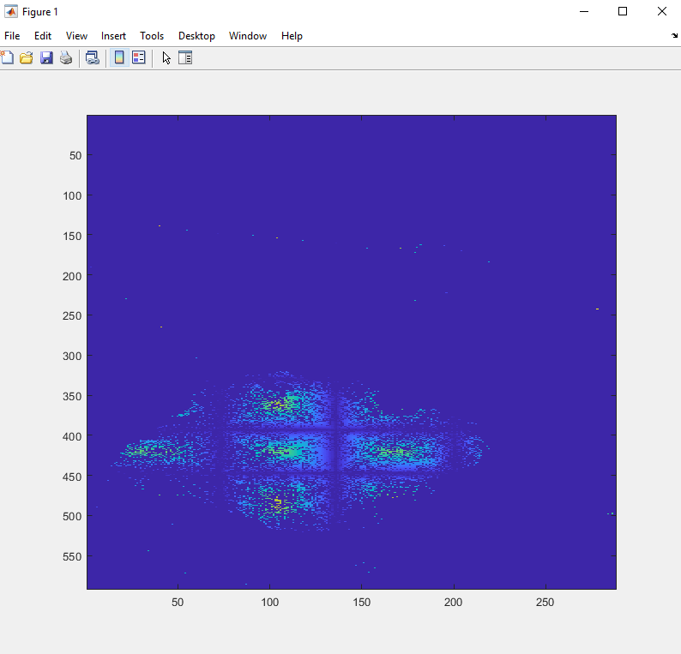

I = 5
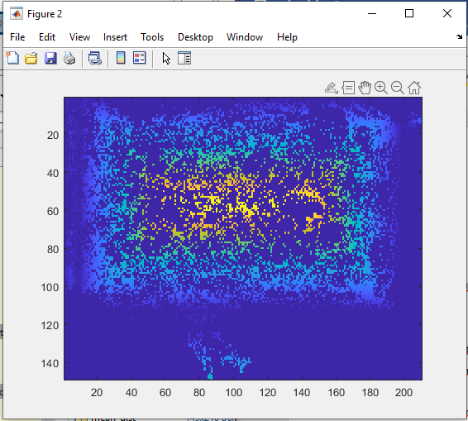

I = 6
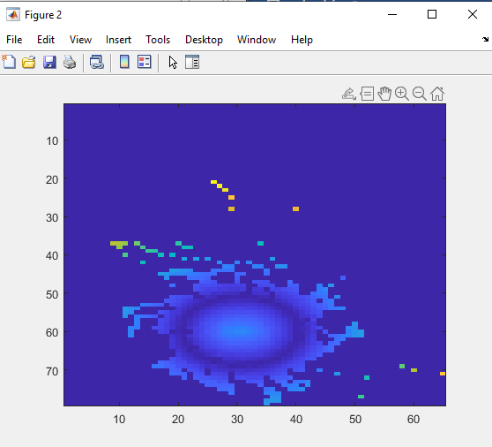

I = 7
